Project Report
Student Record Management System
(SRMS)

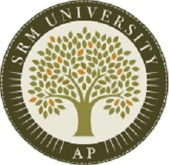

DONE BY:
NAME : B Hitesh Sai
REGISTRATION NO : AP24110010243
CSE 2nd YEAR 3rd SEMESTER
SECTION : N
SUBMITTED TO
RAKESH RAMA RAJU
CODING SKILLS - 1
1. Introduction
The Student Record Management System (SRMS) is a Python-based application designed to manage student academic records efficiently. The system provides secure authentication and role-based access for Admin, Staff, and Guest users. Admin and Staff can create, update, search, and delete student records, while Guest users have view-only privileges. The system stores all user and student data in JSON files, offering a lightweight, portable, and easy-to-manage storage solution without requiring a traditional database.

2. Problem Statement
Many small institutions and departments maintain student records manually, leading to issues such as:
- Data duplication
- Difficulty retrieving or modifying records
- Lack of secure access control
- No proper separation of responsibilities
SRMS addresses these issues by implementing a structured, role-based software system that securely manages student details while ensuring ease of access and modification.

3. Objectives
The main objectives of SRMS are:
- To provide a secure login and authentication system.
- To enforce role-based access control for Admins, Staff, and Guests.
- To enable Admin and Staff users to manage student records effectively.
- To provide Guest users with limited, read-only access.
- To store user and record data in structured JSON files.
- To ensure clean code structure and maintainability.

4. Scope of the Project
The scope of SRMS includes:
- Admin creation (only one admin allowed).
- Staff signup with unlimited accounts.
- User login with password hashing using bcrypt.
- Guest login with view-only permissions.
- Create, view, search, update, and delete student records.
- Admin-exclusive feature to delete all student records.
- JSON-based storage for persistent data.
The system is intended for small-scale data management and does not include advanced database integration or networking features.

5. System Overview
SRMS functions through a simple command-line interface where users interact with menus based on their assigned roles. It contains two major components:
A. Authentication System
Handles:
- Admin signup
- Staff signup
- Login for Admin, Staff, Guest
- Password hashing and verification
B. Record Management System
Handles:
- Student record creation
- Viewing all records
- Searching records
- Updating and deleting specific records
- Deleting all records (Admin only)

6. System Modules
6.1 Authentication Module
This module manages user registration and login. It includes:

- Admin Signup
Only one admin account is permitted.Admin credentials are stored with bcrypt hashing for securit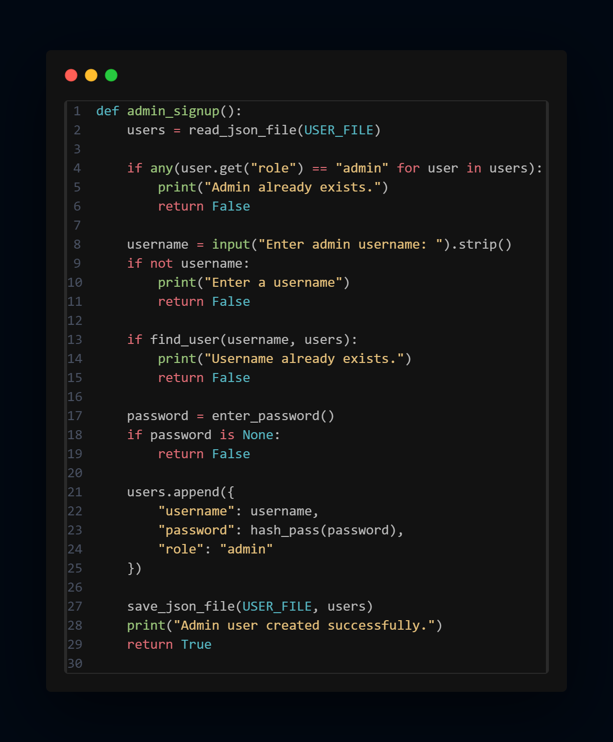

- Staff Signup
Allows creation of multiple staff accounts, each with hashed passwords.
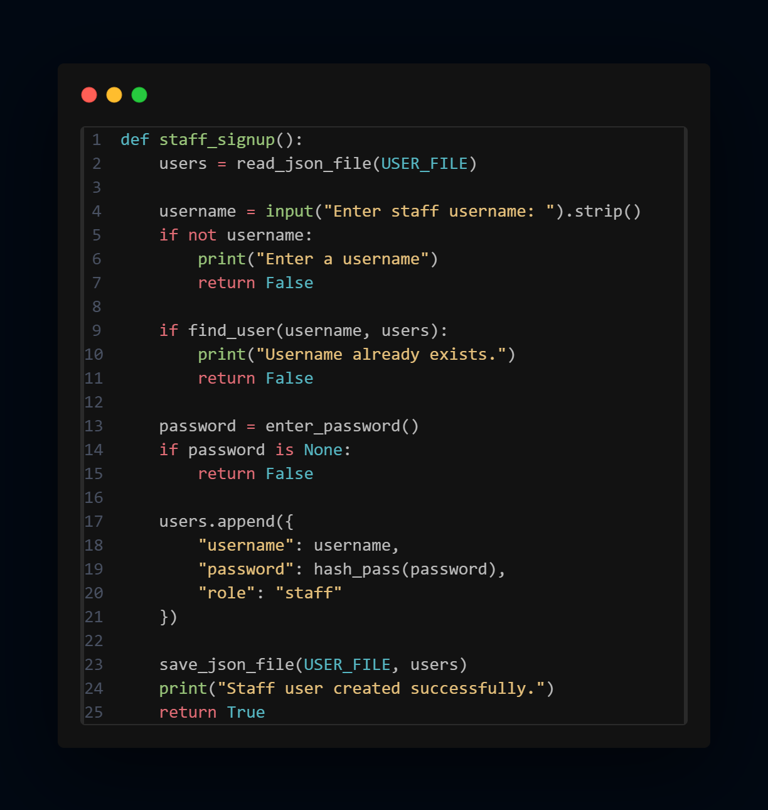

- Login System
Detects username, validates passwords, and authenticates users based on their role.
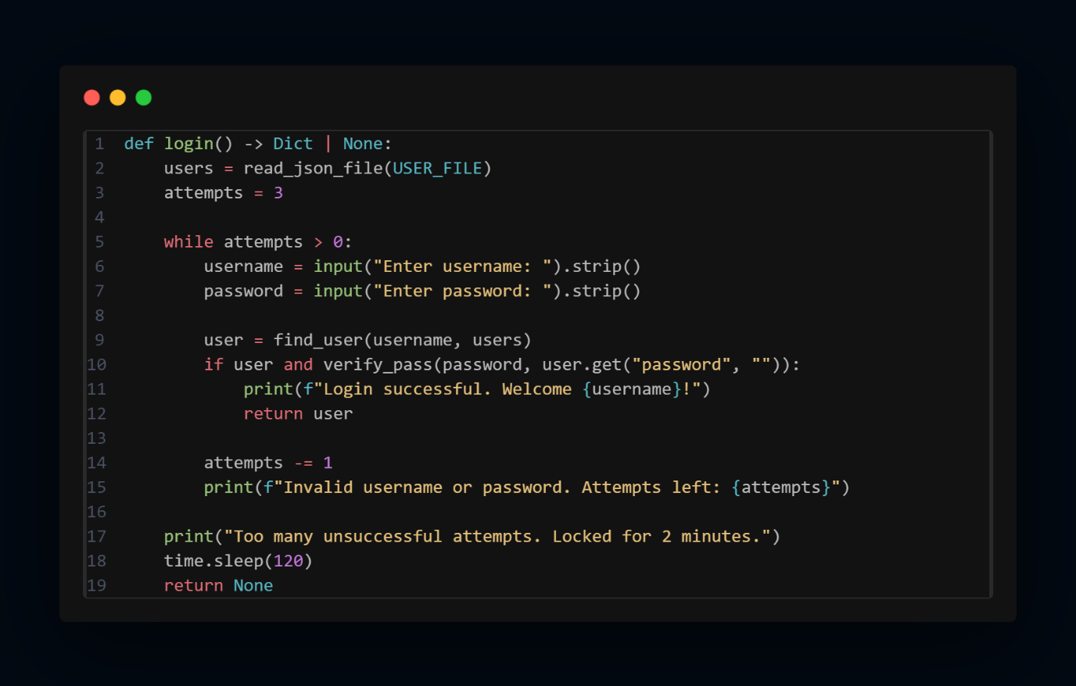

- Guest Login
Provides quick, read-only access without authentication.
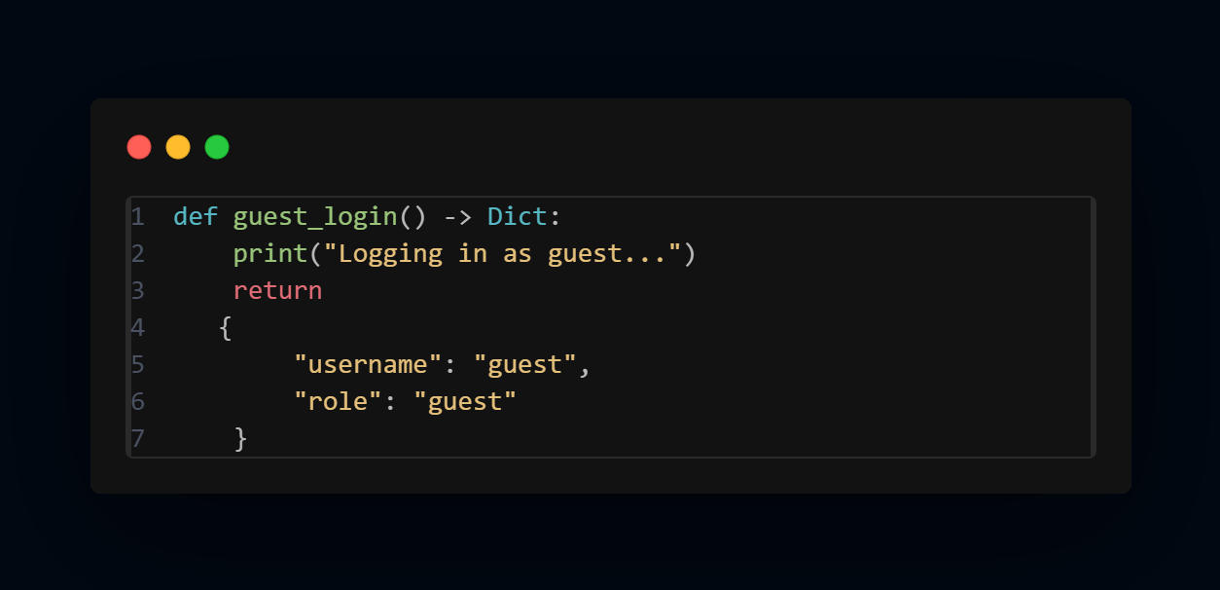
6.2 Record Management Module
This module handles all student-related operations.

- Create Record
Allows Admin and Staff to add new student entries, including ID, name, course, and grade.
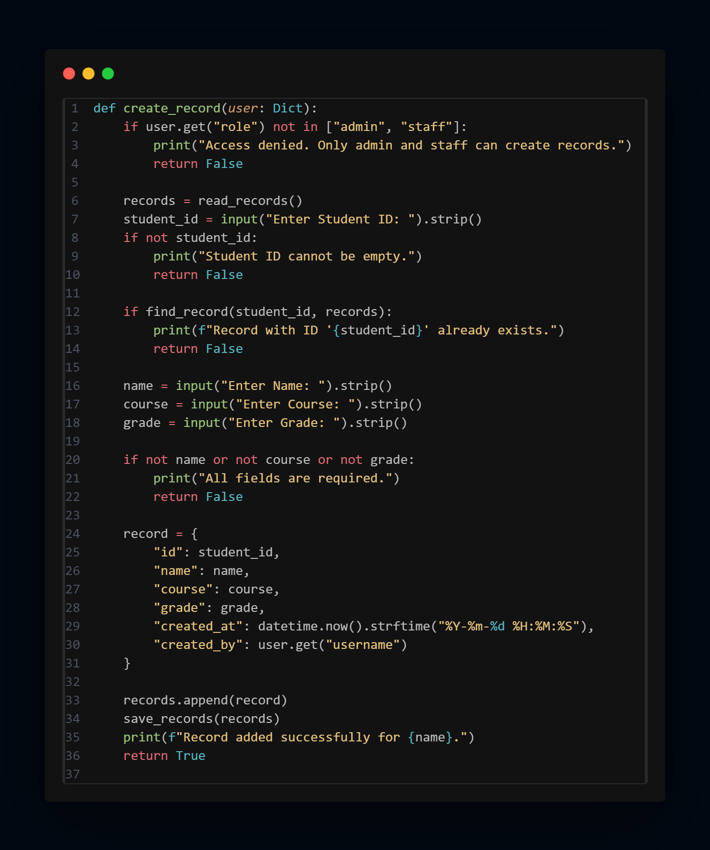
- View All Records
Displays a formatted table of all stored student entries.
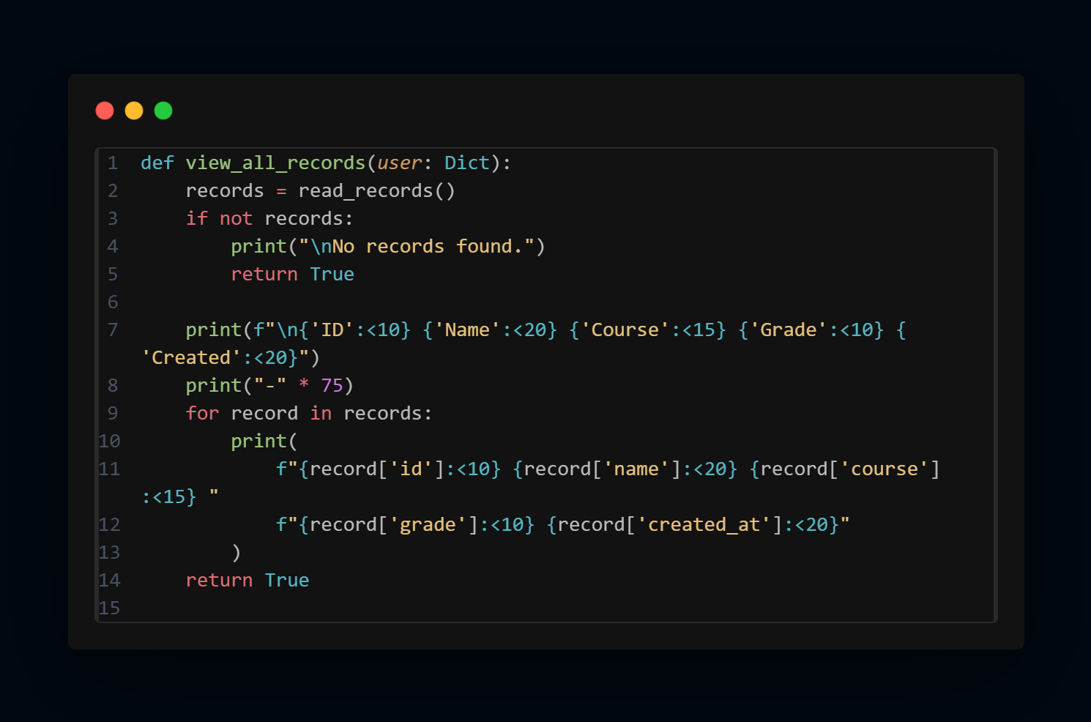
- Search Record
Searches a specific student record by Student ID.
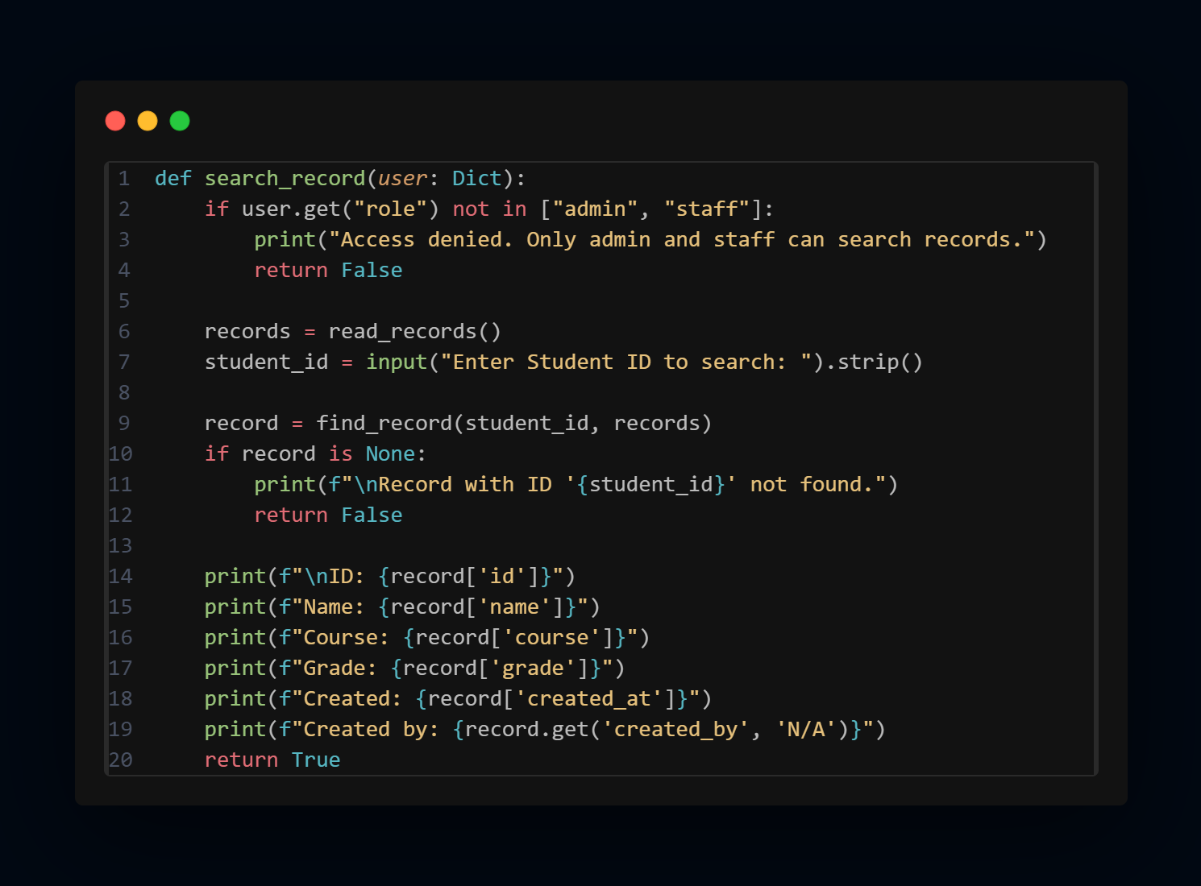

- Update Record
Enables Admin and Staff to modify existing student details.
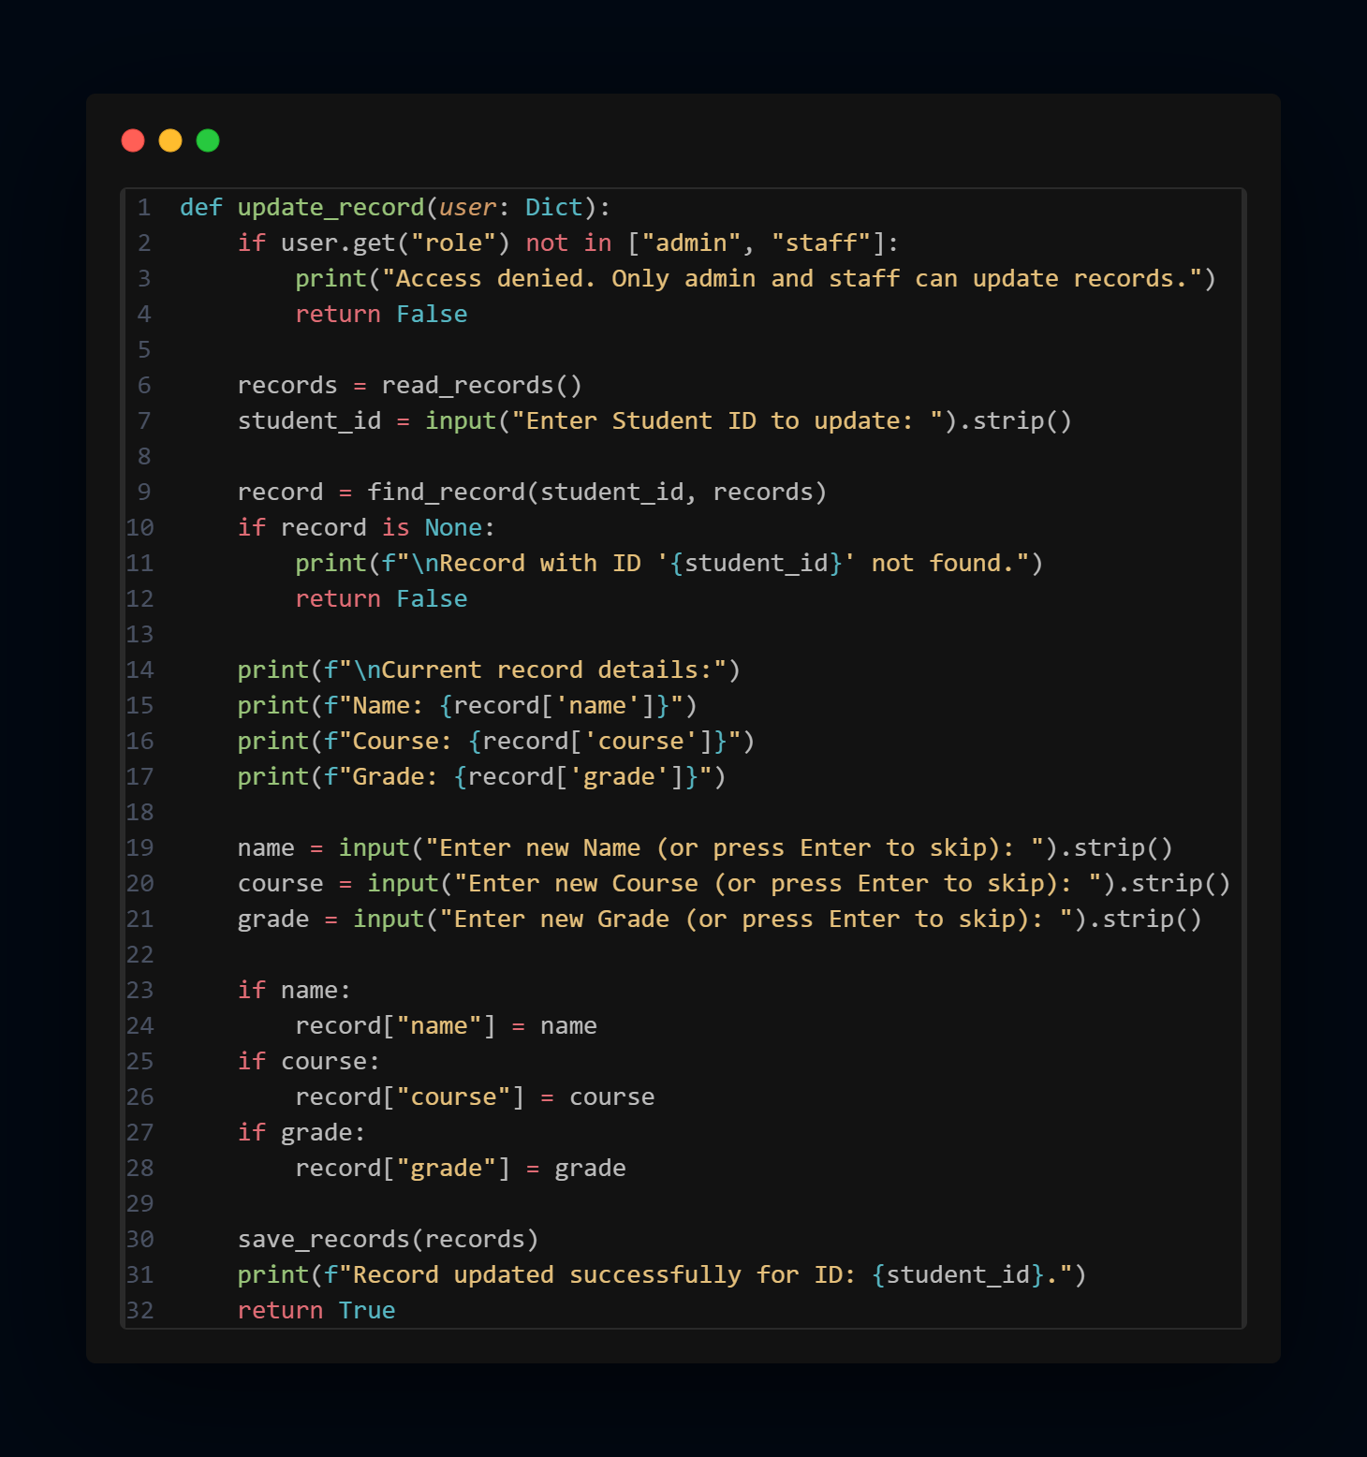

- Delete Record
Removes a student record after confirmation.
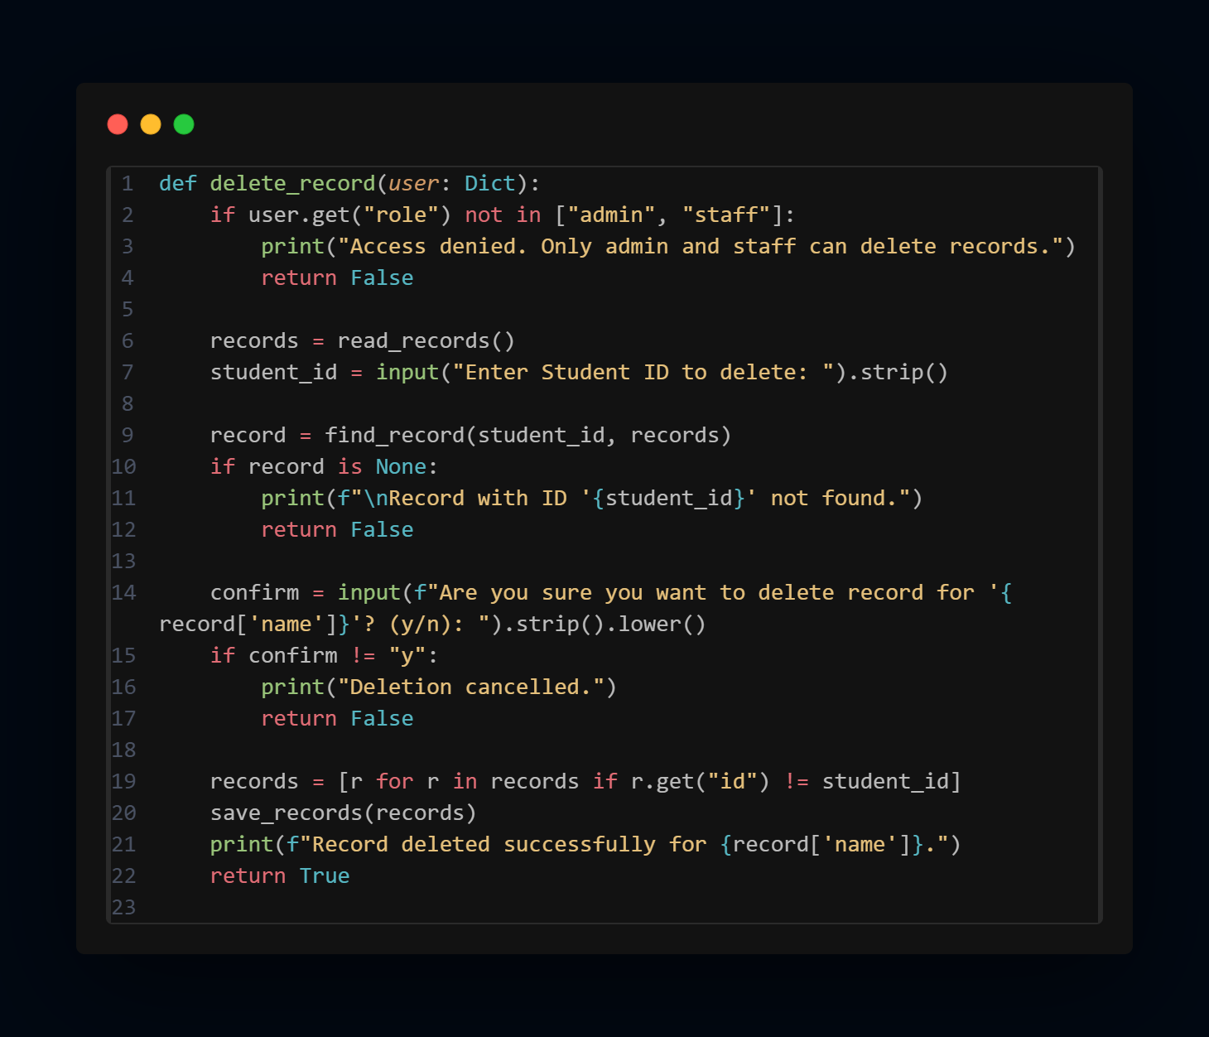

- Delete All Records (Admin only)
Clears all entries from the records JSON file.
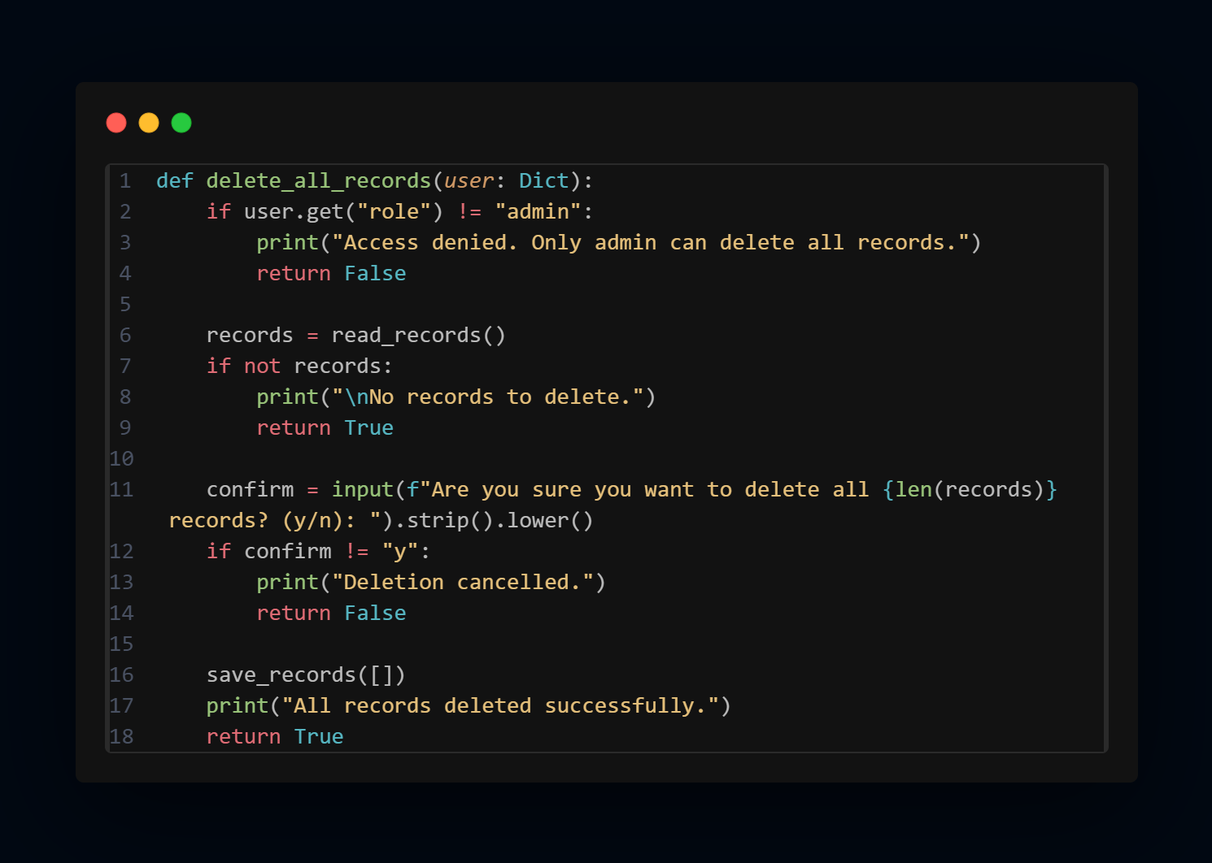

7. Data Storage
SRMS uses two JSON files:
1. users.json
Stores:
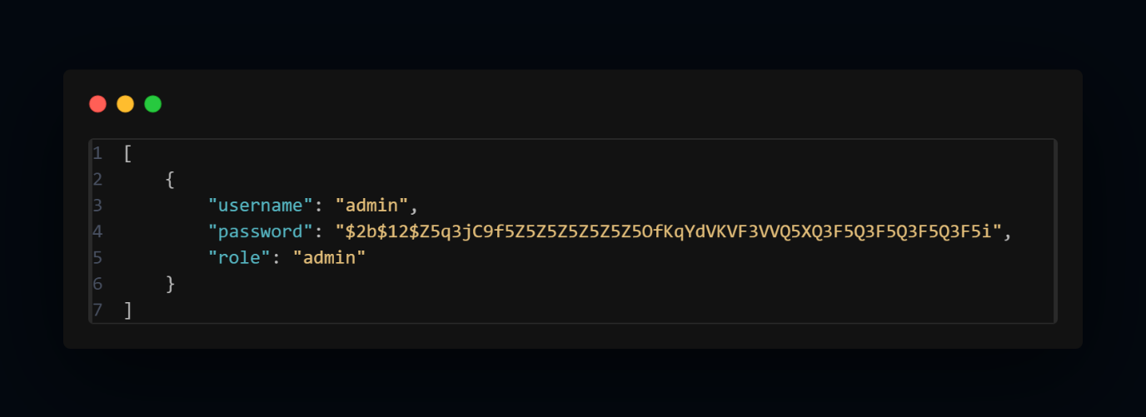

2. records.json
Stores:
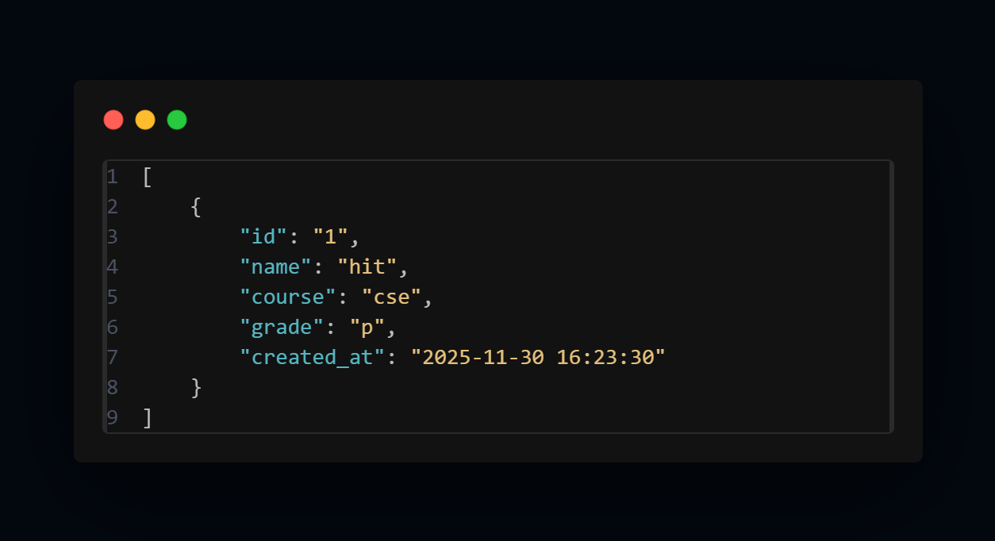
JSON storage provides:
- Simplicity
- Human readability
- Compatibility across systems

8. System Workflow
- User opens SRMS application.
- Authentication menu is displayed.
- User chooses to sign up (Admin/Staff), login, guest login, or exit.
- After login, main menu options are displayed based on user role.
- User performs relevant operations (CRUD).
- System updates appropriate JSON files.
- User logs out and returns to the main authentication menu.

9. Implementation Details
Programming Language: Python
Libraries Used:
- bcrypt → Secure password hashing
- json → Data storage
- datetime → Timestamp generation
Key Features Implemented:
- Role-based access control
- Secure login authentication
- Persistent storage using JSON
- Time-stamped records for auditing
- Input validation and error handling
- Command-line menu-based interface

10. Testing
Various test cases were executed to validate:
- Admin signup limit
- Staff signup and login
- Incorrect password handling
- Create, update, delete record functionality
- Search and view operations
- Guest access restrictions

11. Conclusion
The Student Record Management System (SRMS) provides a lightweight yet secure solution for managing academic records. With role-based access, password hashing, and structured JSON storage, SRMS ensures proper segregation of duties and secure handling of data. Its modular design allows easy additions and modifications, making it suitable for small institutions or as a base system for future expansion.

